
MNS University of Agriculture, Multan
Institute of Computing
PROJECT
📝 IT-506 Web Technologies

Title:
Digital Sticky Wall
Submitted by:
Muhammad Uzair Asghar 2023-uam-2186
M. Areeb ul Hassan 2023-uam-2187
Saif Ashraf 2023-uam-2185
Submitted to:
Instructor: Ms. Jannat Aziz
Date of Submission:

1. Introduction
The Digital Sticky Wall is an interactive, full-stack web application designed to help users organize their thoughts, tasks, and ideas in a visually appealing workspace. Developed as a Web Technologies semester project, the application replicates the real-world experience of placing sticky notes on a wall, enhanced with digital capabilities such as real-time search, session-based persistence, and dynamic sorting. It features a modern "Glassmorphism" user interface, providing a clean and intuitive user experience.
2. Project Objectives
- To build a seamless Single Page Application (SPA) where users can create, manage, and delete notes without page reloads.
- To implement a robust backend REST API for handling data operations.
- To ensure data persistence using server-side JSON file storage.
- To provide isolated user experiences using session tracking and signed cookies, ensuring that users only interact with their own notes.
3. Key Features & Functional Requirements
The application provides the following core features:
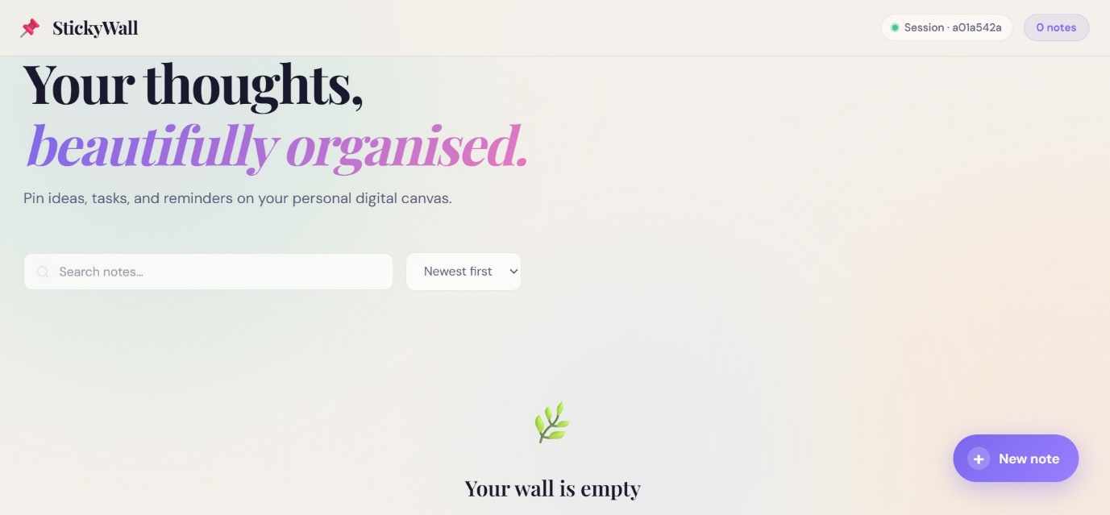
- Modern UI/UX: A responsive Glassmorphism design with animated, pastel-colored note cards.

- CRUD Operations via AJAX: Users can add and delete sticky notes seamlessly in real-time.
- Advanced Filtering & Sorting: Includes real-time search functionality and sorting options (Newest, Oldest, A→Z).
- Customization: Users can assign up to 8 different pastel colors to their note cards.
- Session Management: Secure session tracking where notes are scoped only to the active user's session (persisting for 7 days).
- Keyboard Shortcuts: Built-in accessibility (e.g., Ctrl+N for a new note, Ctrl+K to search, and Esc to close modals).
- Dynamic Timestamps: Auto-refreshing time indicators (e.g., "2 min ago") for better context on note creation.
4. System Architecture
The application follows a standard Client-Server architecture:
- Frontend (Client-Side): A Single Page Application (SPA) shell that manages state, DOM manipulation, and API fetching natively.
- Backend (Server-Side): An Express.js server that processes HTTP requests, handles session generation, and manages the file system.
- Storage (Database Layer): An in-memory and persistent storage hybrid utilizing data/notes.json for lightweight, reliable data saving.
5. Technology Stack
The project was developed using the following technologies:
- Frontend: HTML5, CSS3, and Vanilla JavaScript
- Backend: Node.js with the Express framework
- Session Management: express-session and cookie-parser
- Unique Identifiers: uuid v4 for generating unique note and user IDs
- Storage: In-memory + JSON File Persistence
- Typography: Playfair Display and DM Sans fonts
6. Project Structure Overview
The repository is modularized to separate the client and server concerns:
- server.js: The entry point for the backend, defining routes, sessions, and APIs.
- data/notes.json: Auto-generated persistent storage file for notes.
- public/index.html: The core HTML structure for the application.
- public/style.css: Contains all visual properties, glassmorphism logic, and animations.
- public/app.js: The frontend script responsible for DOM events, state management, and Fetch API calls.
7. REST API Endpoints
The backend provides a structured RESTful API for client-server communication:
- GET /api/notes – Retrieves all notes associated with the current user's session.
- POST /api/notes – Creates a new sticky note (requires a JSON body with title, description, and color).
- PATCH /api/notes/:id – Updates the title or description of a specific note.
- DELETE /api/notes/:id – Deletes a specific note.
- GET /api/session – Retrieves the current session's metadata.
- GET /api/stats – Fetches statistical data on the notes created by the current user.
8. Data Security and Persistence
To ensure a secure and personalized experience without requiring full user authentication:
- Sessions: Every visitor is assigned a unique userId via express-session.
- Cookies: An sw_user cookie is provided, which the frontend uses to maintain scope.
- Isolation: The backend maps all notes to the session ID, ensuring users cannot view or manipulate sticky notes belonging to other active sessions.
- 9. Conclusion
The Digital Sticky Wall successfully fulfills the requirements of a modern web application. By avoiding heavy frontend frameworks and relying on Vanilla JavaScript combined with a Node.js backend, the project demonstrates a strong fundamental understanding of REST APIs, asynchronous JavaScript, session management, and modern CSS design principles.

